**Operating System Day 1**

**Q.1 Tangible vs Intangible**

**Tangible:**

1. Tangible assets can be referred to as the long-term resources which are physical and that are owned by an organization or the corporation, which has some economic value.
2. Examples for the same would be plants & machinery, buildings, vehicles, tools & equipment, furniture & fixtures, land, computers, etc.
3. These assets mostly suffer from the risk of loss due to theft, fire, accident, or any other such disaster. Tangible assets do have a useful economic life, after which it has the risk of becoming obsolete.

**Intangible:**

1. These assets are the long-term resources that are incorporeal that is also owned by the organization, which have a specific commercial value.
2. Examples of intangible assets incude trademark, goodwill , copyright, patent, brand, blueprint, Internet domains, intellectual property, licensing agreements, etc.
3. Intangible assets are nonphysical long-term assets. Because intangible assets are generally intellectual assets, assigning a value to them is challenging due to the unpredictability of future benefits.

**Q.2 Editor-Linker-Loader**

**Linker:**

1. A linker is special program that combines the object files, generated by compiler/assembler, and other pieces of codes to originate an executable file have. exe extension.
2. In the object file, linker searches and append all libraries needed for execution of file.
3. It also merges two or more separate object programs and establishes link among them.
4. Linkers are of 2 types: Linkage Editor and Dynamic Linker.

**Loader:**

1. The loader is special program that takes input of executable files from linker, loads it to main memory, and prepares this code for execution by computer.
2. Loader allocates memory space to program.
3. It is in charge of loading programs and libraries in operating system.
4. Loaders are of 4 types: Absolute, Relocating, Direct Linking, Bootstrap.

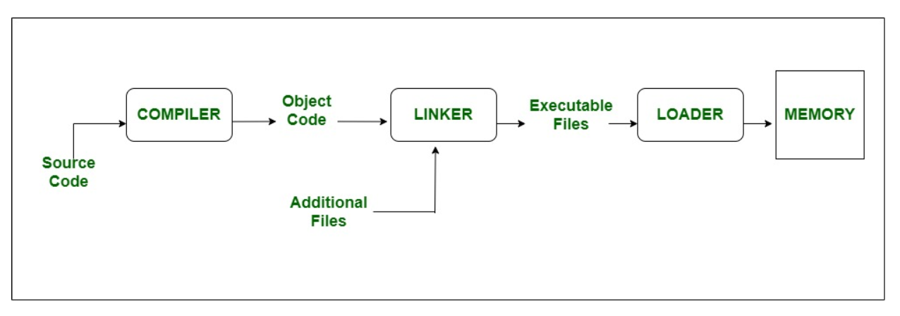

**Q.3 Linkage Error**

1. LinkageError indicate that a class has some dependency on another class; however, the latter class has incompatibly changed after the compilation of the former class.
2. Linkage error is an example that explains us the sequence of editor, linker and loader.
3. Editor comes first as we use editor to edit the program, then the linker is used to link all the libraries needed for the execution of that file and then loader oads the program and the libraries into operating system.

**Q.4 Debugger and how it works**

1. Debugging is the process of analyzing how your program runs, how it generates data in order to find defects and issues in your code.
2. These errors or defects are referred to as “bugs”, hence the term “debugging.”
3. A debugger is a tool that is typically used to allow the user to view the execution state and data of another application as it is running.
4. Debuggers allow users to halt the execution of the program, examine the values of variables, step execution of the program line by line, and set breakpoints on lines or specific functions that, when hit, will halt execution of the program at that spot.

**Q.5 Find the Error**

**Code:**

Class Abhishek

{

public static void main(Sring args[])

{

System.out.print(“Hello World”);

}

a = 3;

}

**Error:**  <Identifier> expected

Resources:

Operating System: <https://www.geeksforgeeks.org/last-minute-notes-operating-systems/>

Linker, Loader:

<https://www.geeksforgeeks.org/difference-between-linker-and-loader/#:~:text=The%20main%20function%20of%20Linker,executable%20files%20to%20main%20memory.&text=The%20linker%20takes%20input%20of,executable%20files%20generated%20by%20linker>.

Debugger:

<https://www.jetbrains.com/help/idea/debugging-your-first-java-application.html>